Image | 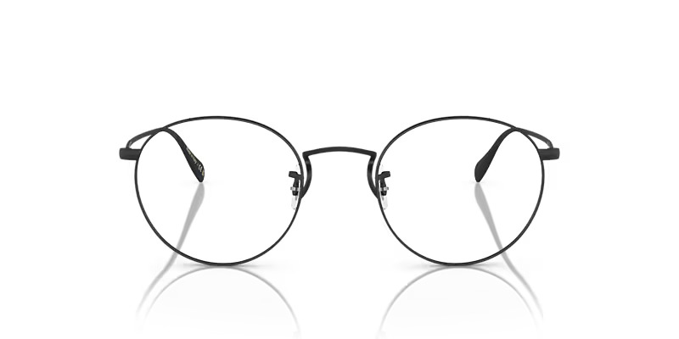
Brand | DIOR
Model Name | COLERIDE
Price | RS 1499
PRODUCT DETAILS

